**Time of Check**

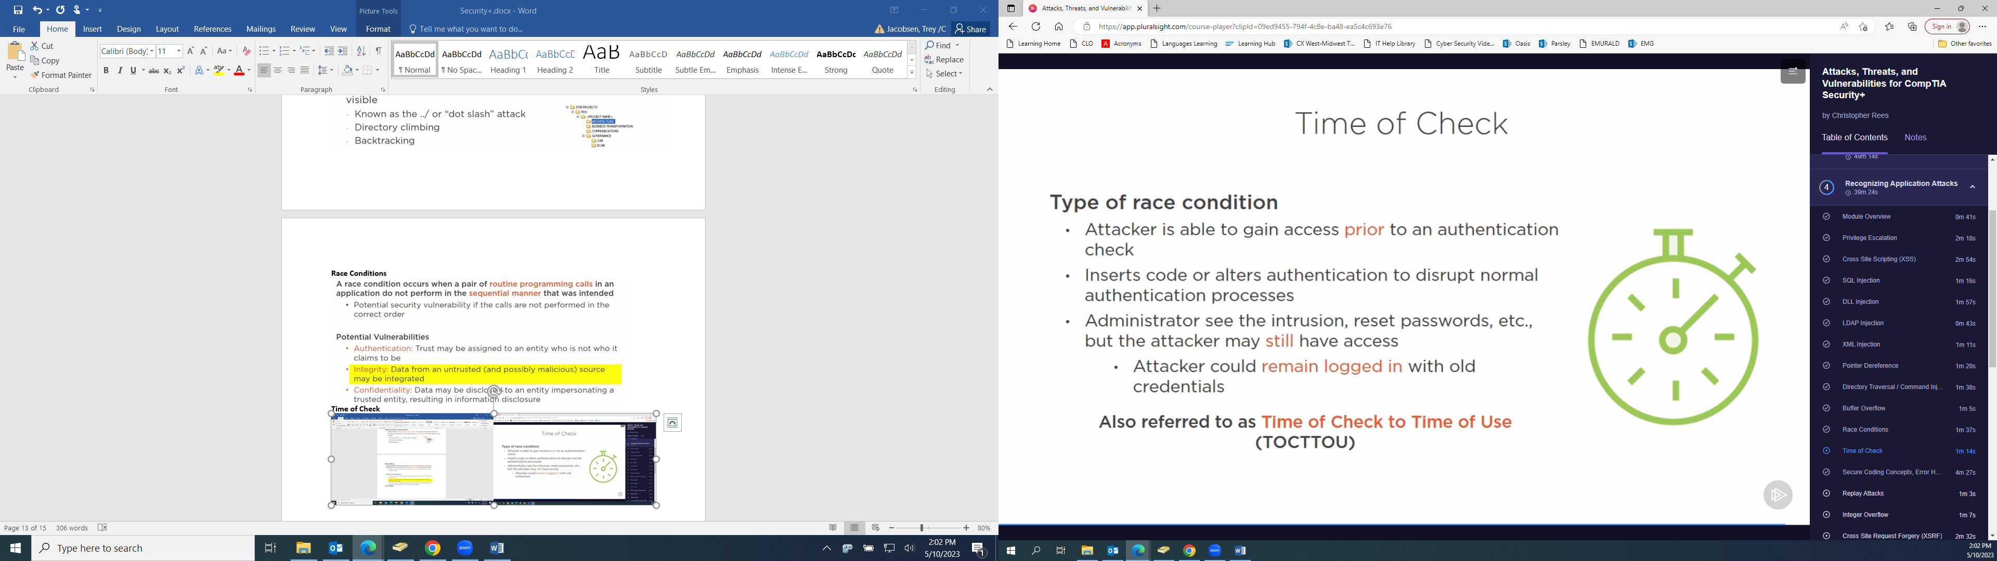

**Secure Coding Concepts**

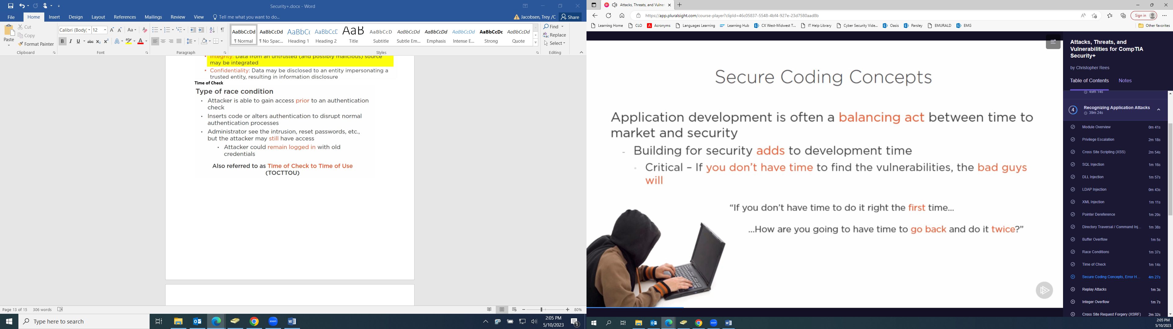

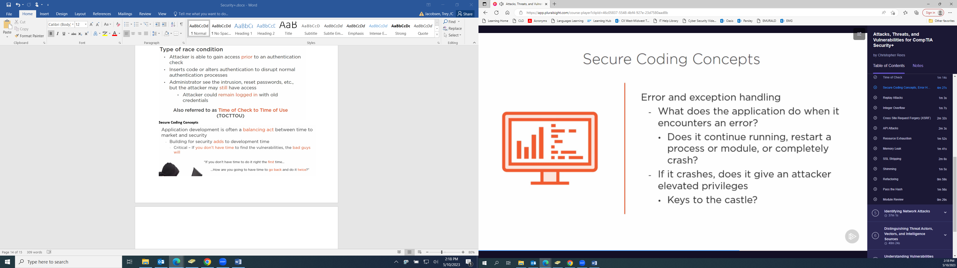

**Make sure error handling is not too specific on deployment so that attackers can’t exploit issues.**

**Input validation: Always validate input and even output, any data should be checked as it moves from one system to another.**

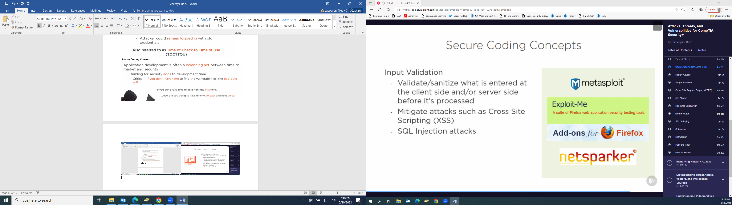

**Open Web Application Security Project (OWASP):** [**https://www.owasp.org/index.php/OWASP_Secure_Coding_Practices_-_Quick_Reference_Guide**](https://www.owasp.org/index.php/OWASP_Secure_Coding_Practices_-_Quick_Reference_Guide)

**CERT:** [**www.cert.org/secure-coding**](http://www.cert.org/secure-coding)

**Replay Attack**

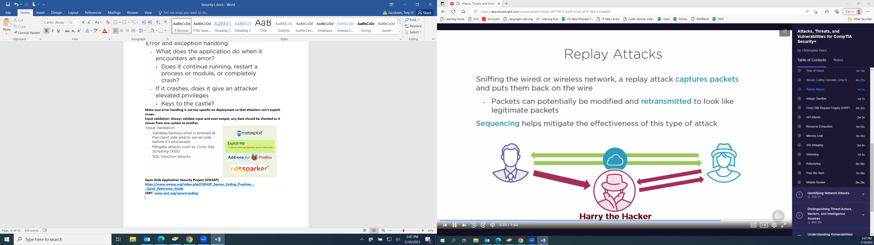

**Integer Overflow**

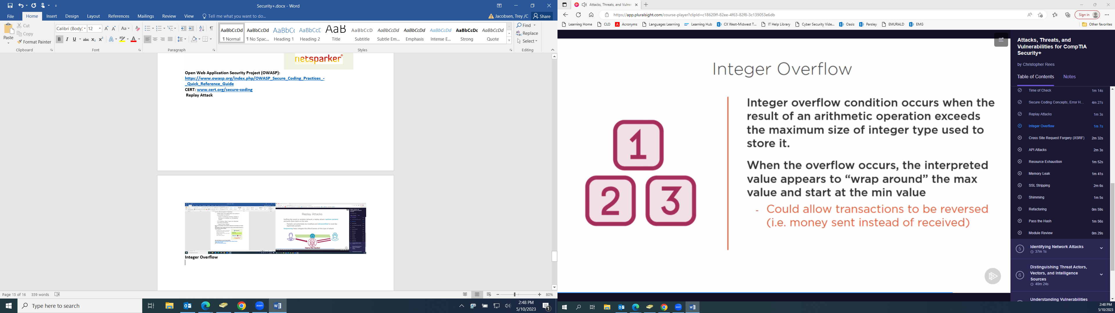

**Cross Site Request Forgery (XSRF)**

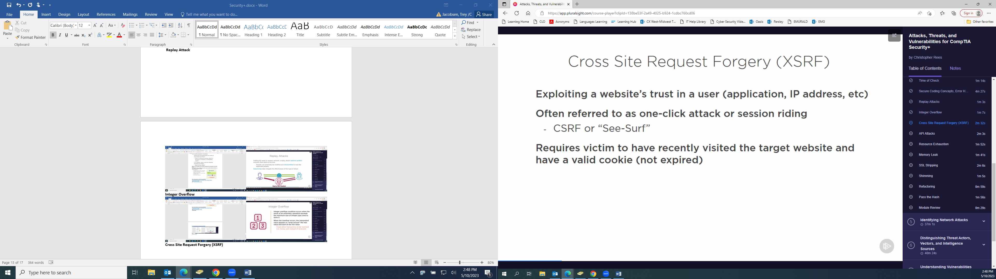

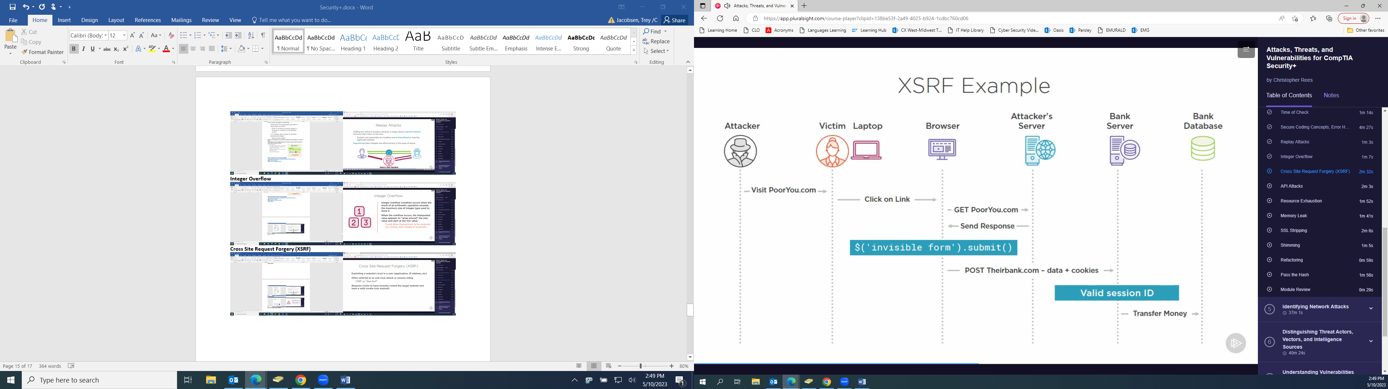

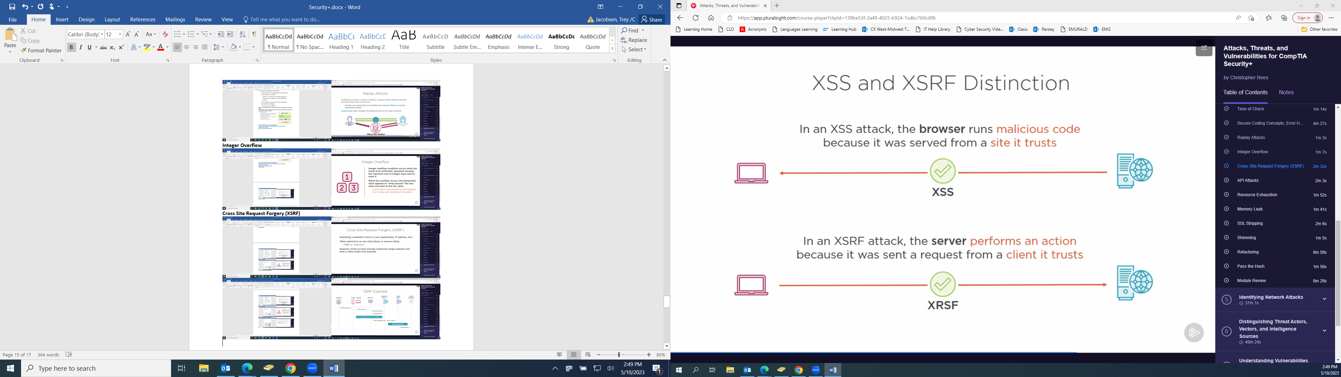

**Application Programming Interface (API) Attacks**

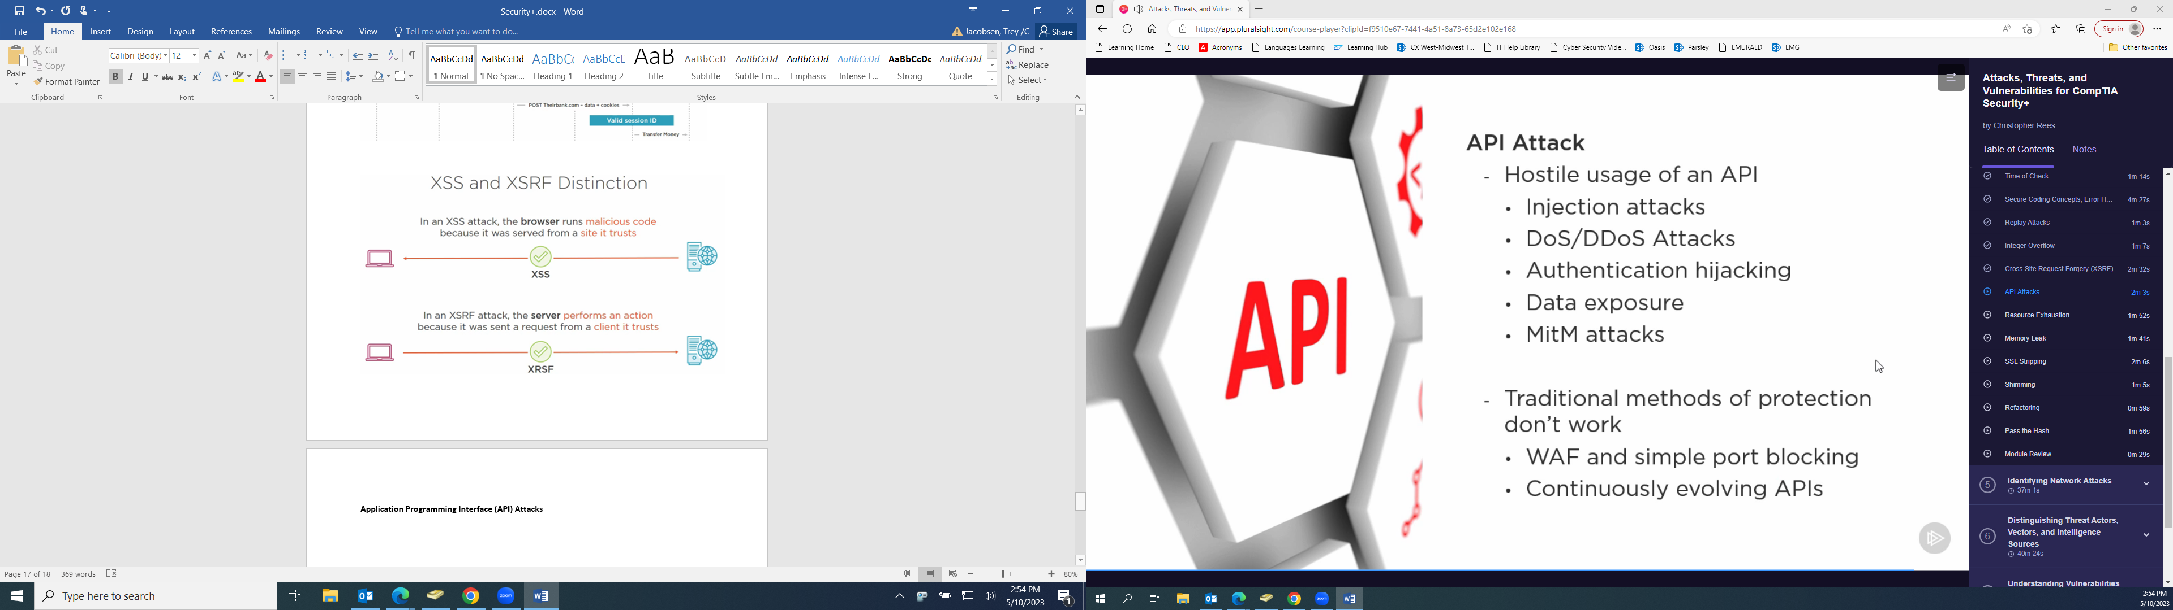

**Resource Exhaustion**

**Denial of Service (DoS) or Distributed Denial of Service (DDoS)**

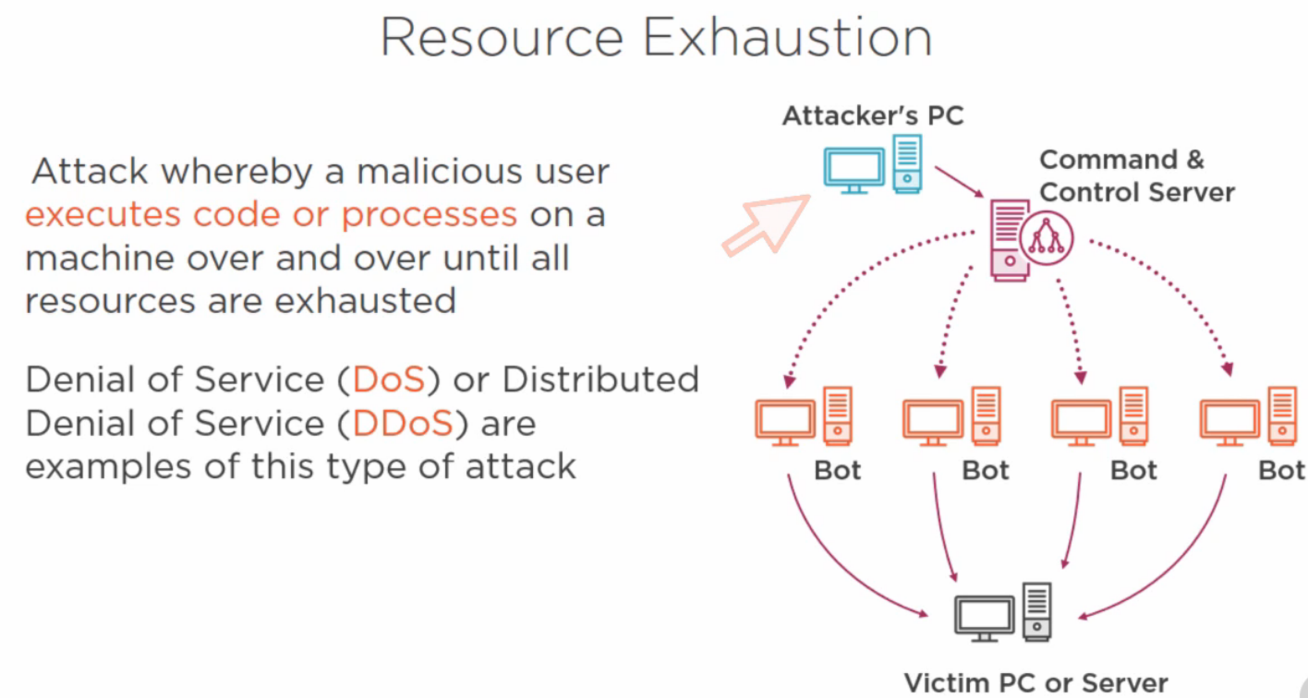

**Memory Leak**

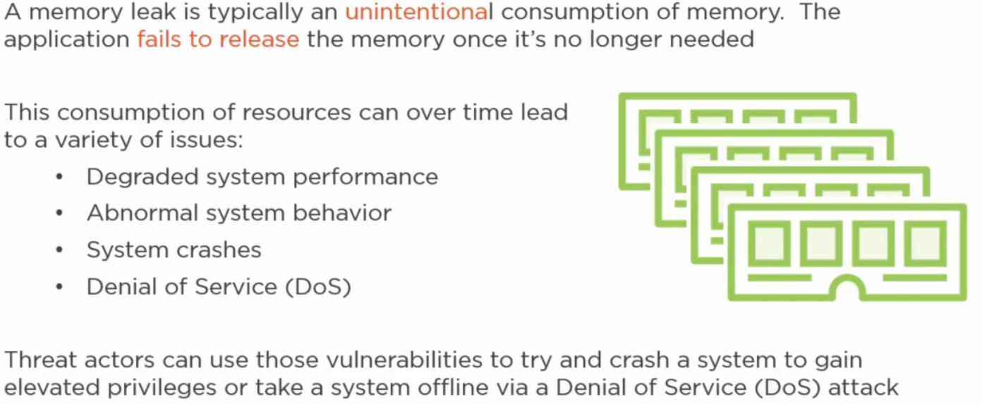

**SSL Stripping (Man in the Middle (MitM) attack)**

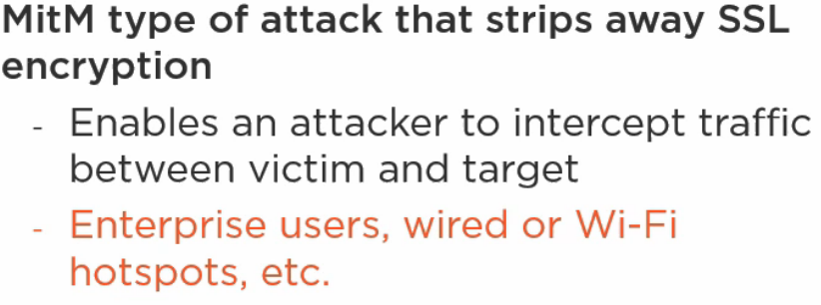

**SSL Stripping Mitigations**

**HTTP Strict Transport Security (HSTS)**

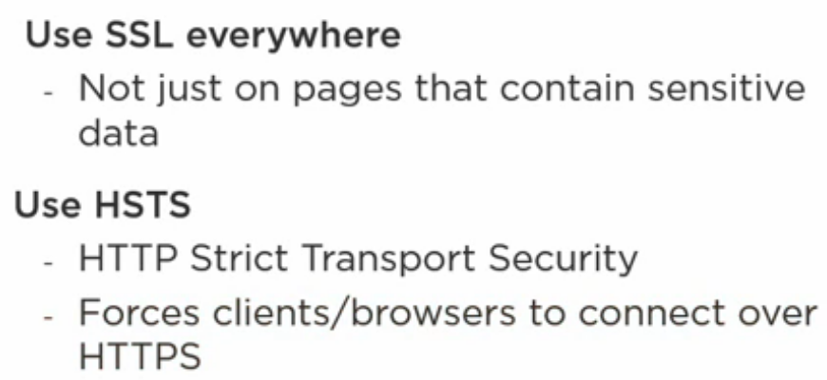

**Shimming**

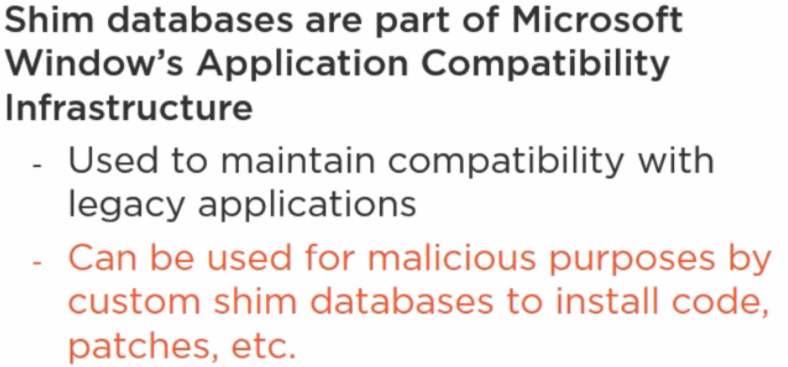

**Refactoring (Purpose): Fix bugs, patch code, and tighten up security without changing or adversely affecting the underlying functionality.**

**Pass the Hash: Harvesting a user’s password hash to authenticate to a remote server or service.**

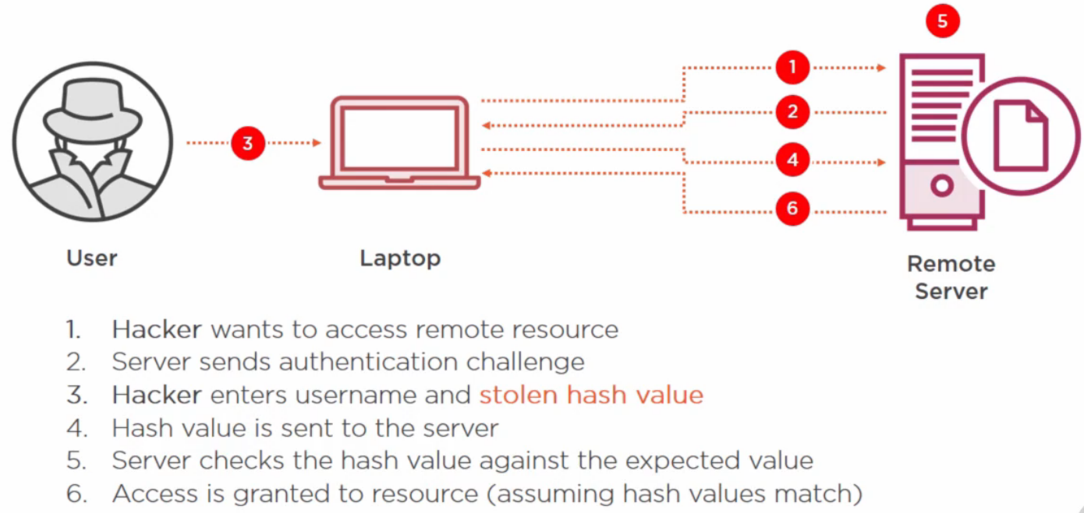

**Rogue Access Points**

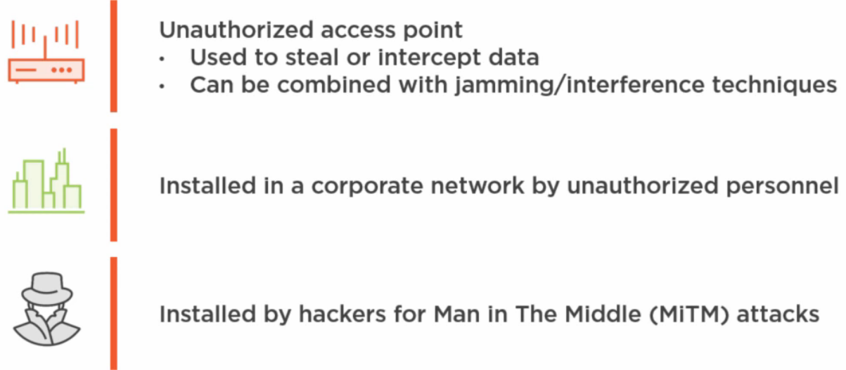

**Evil Twin: Rogue access point that is impersonating a legitimate access point – using the same SSID.**

**Bluejacking: Sending of unauthorized messages or data to a victim’s device via Bluetooth technology. Typically sending a vCard containing a message in the name field to another Bluetooth-enabled device via OBjectEXchange (OBEX) protocol.**

**Bluesnarfing: Opposite of Bluejacking where data is pulled off the victim device.**

* **Contact lists**
* **Pictures**
* **Text messages**
* **Emails**
* **Personally Identifiable Information (PII)**

**Dissociation**

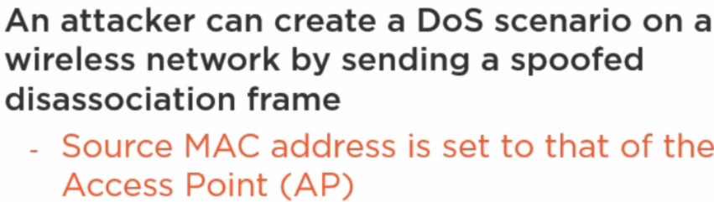

**[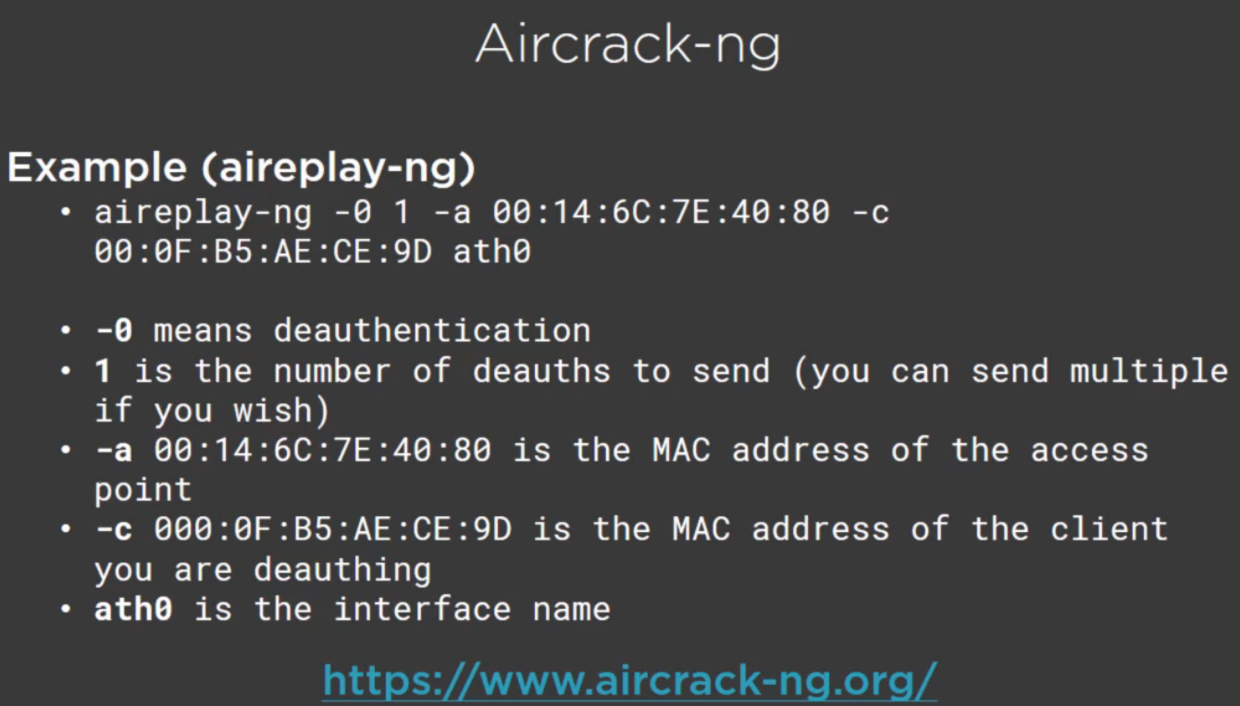](http://www.aircrack-ng.org/)**

**Jamming**

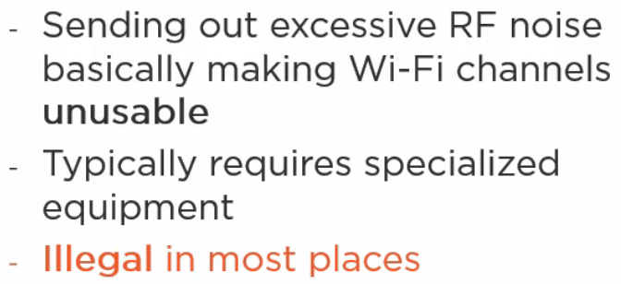

**Radio Frequency Identification (RFID)**

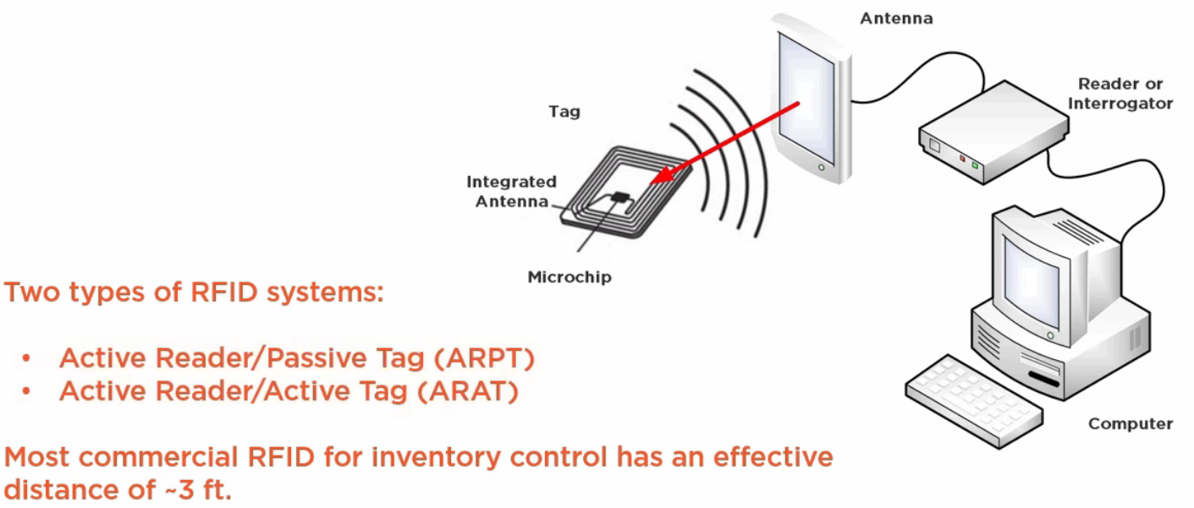

**Near Field Communication (NFC)**

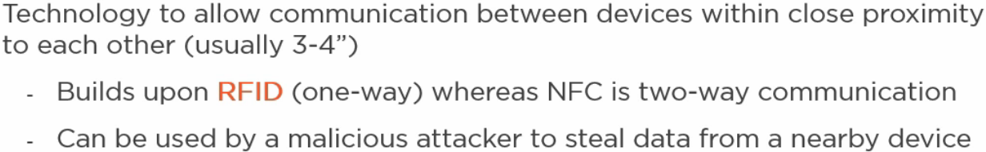

**IV Attack**

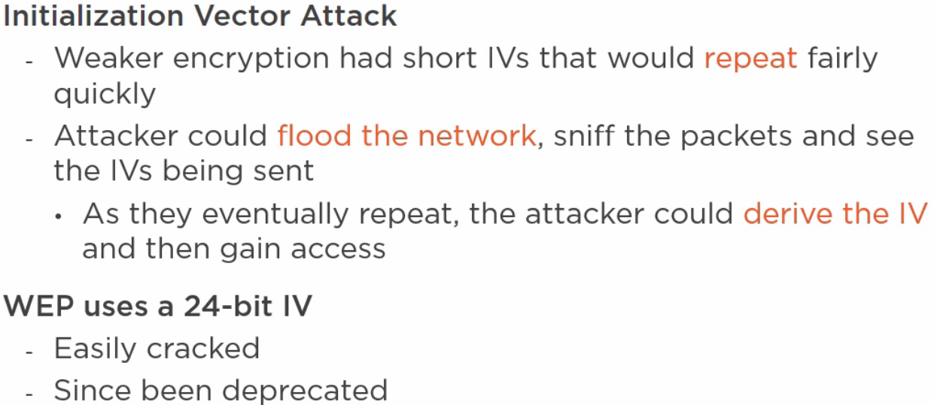

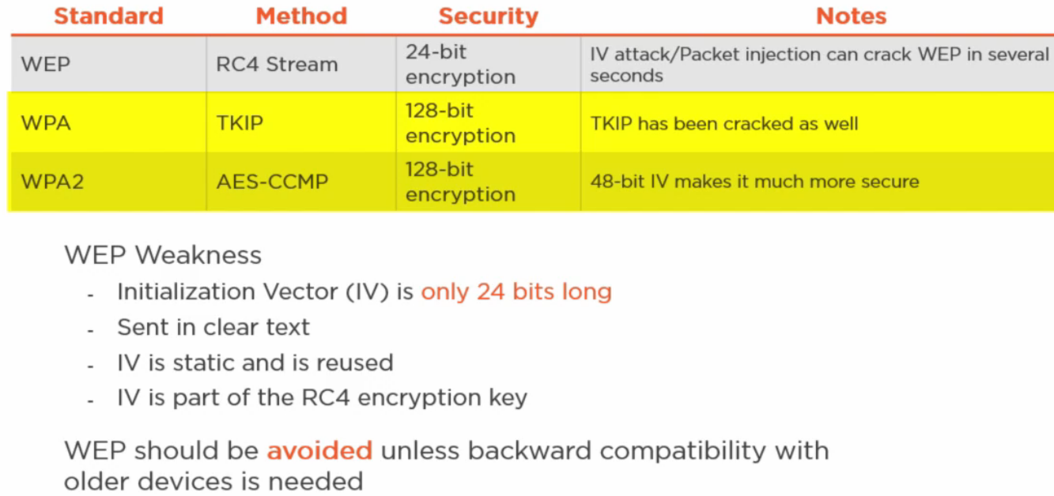

**On-path Attacks**

* **Man-in-the-Middle (MitM)**
* **Man in the Browser (MitB)**

**ARP Poisoning**

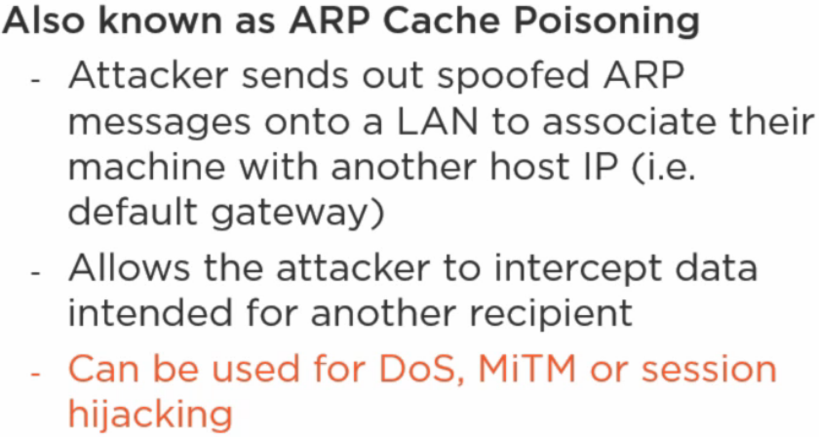

**IP/MAC Spoofing**

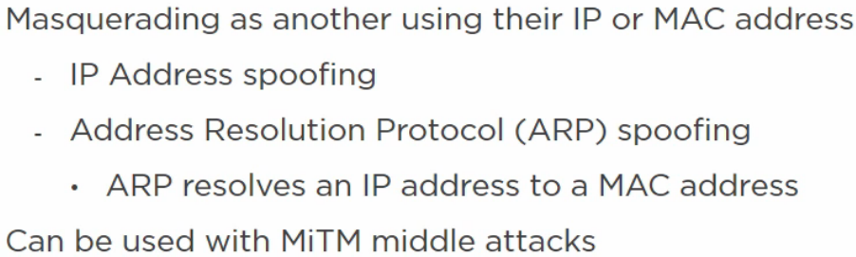

**MAC Flooding: Flooding switch with HTTP requests from various MAC addresses to overload the switch, limit user functionality on other systems, and receive information that is input by other users**

**MAC Cloning**

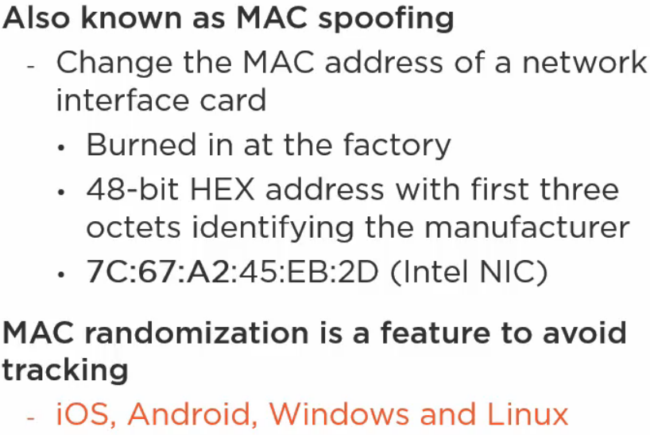

**DNS Poisoning**

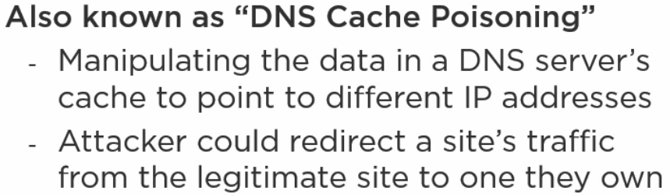

**Typo Squatting/URL Hijacking**

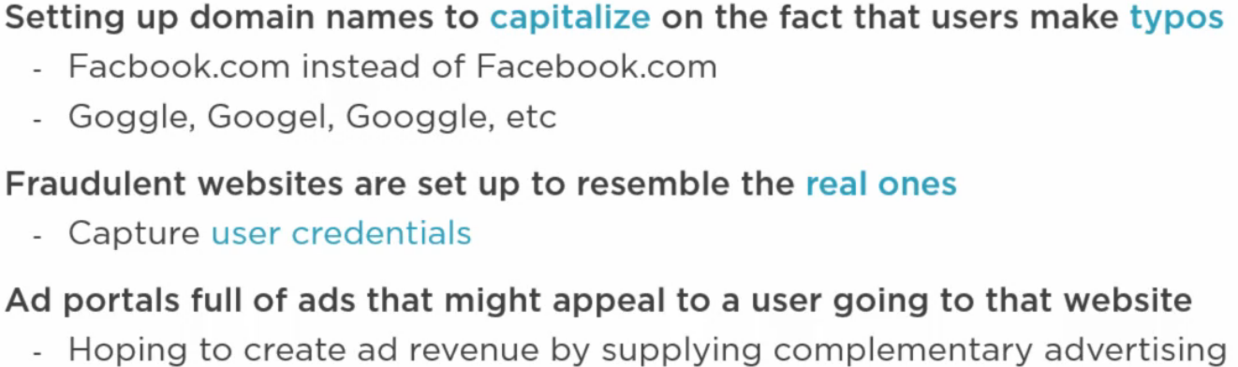

**DDoS**

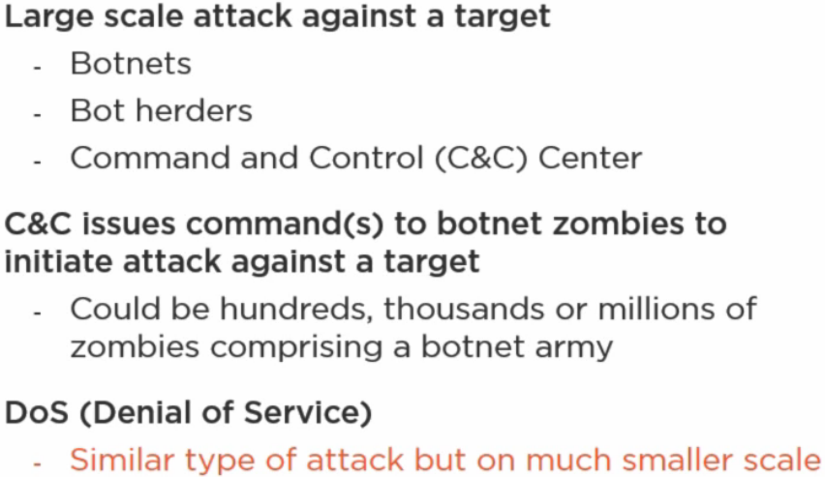

**Smurf Attack**

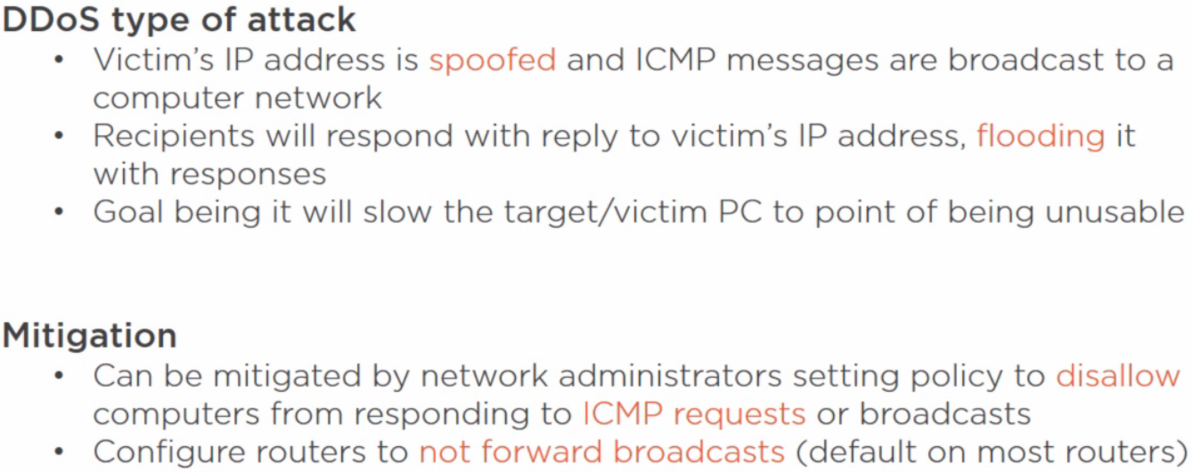

**Distributed Denial of Service (DDoS) attacks**

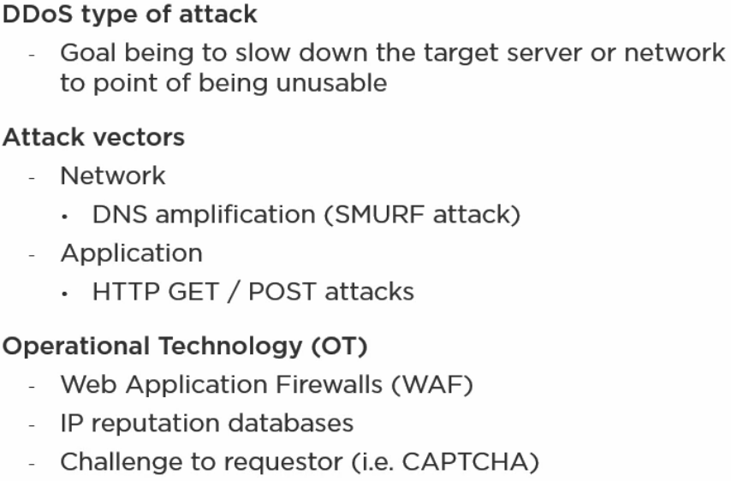

**Malicious Code Execution**

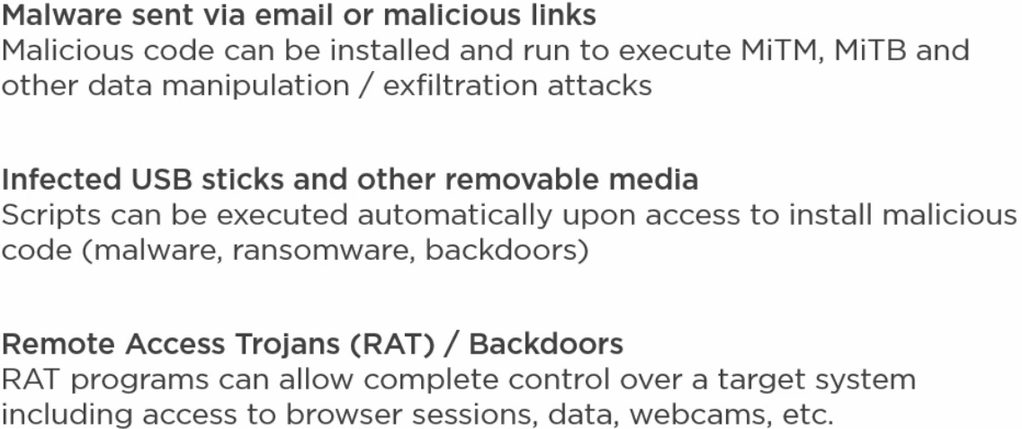

**Script Kiddies**

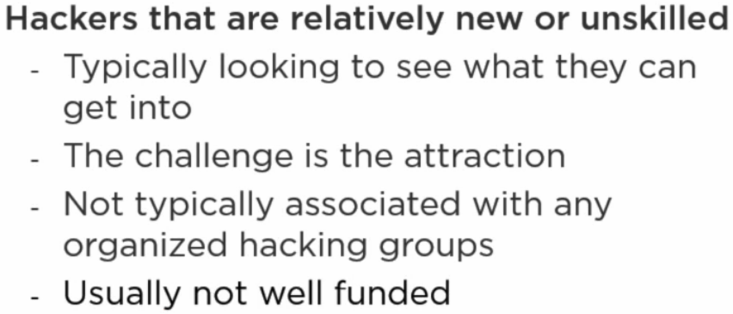

**Hacktivists**

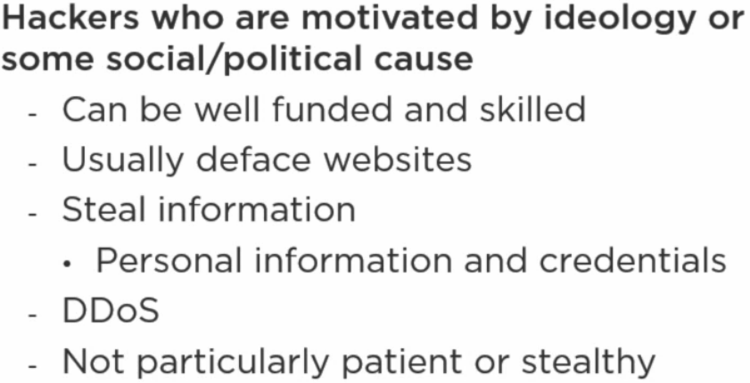

**Organized Crime**

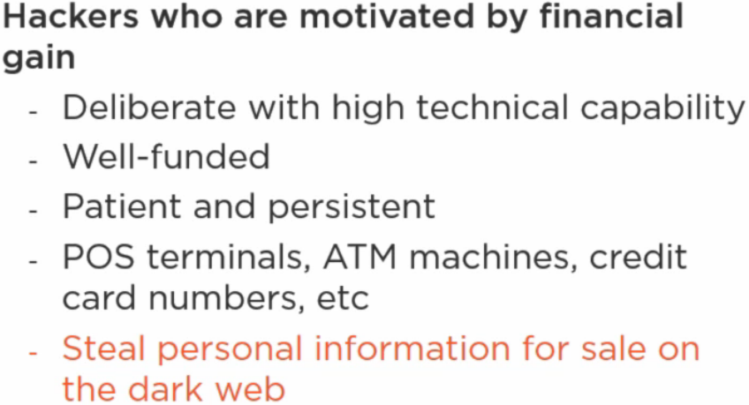

**Nation States and Advanced Persistent Threats (APT)**

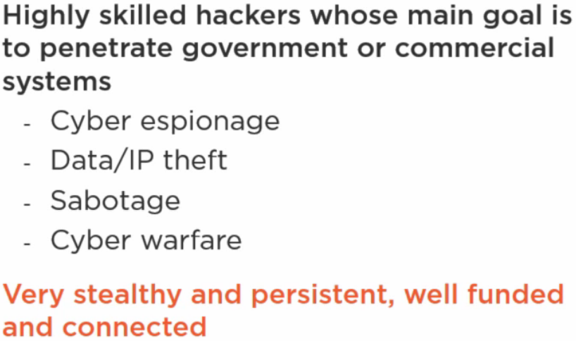

**Insiders**

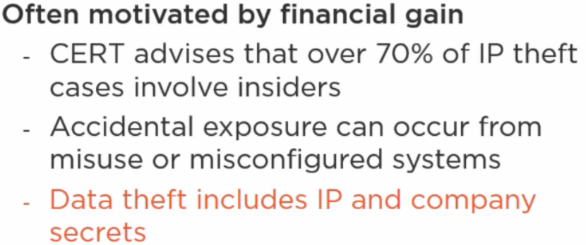

**Competitors**

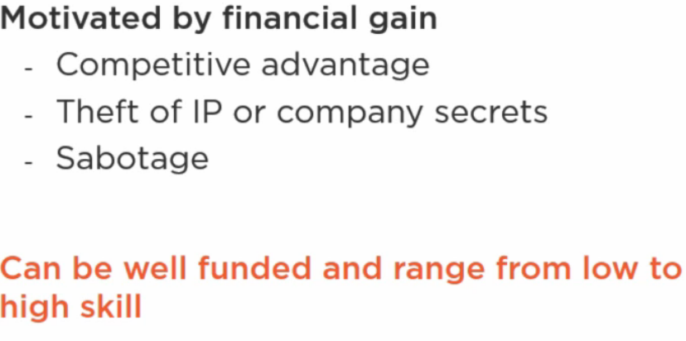

**Threat Actor Attributes**

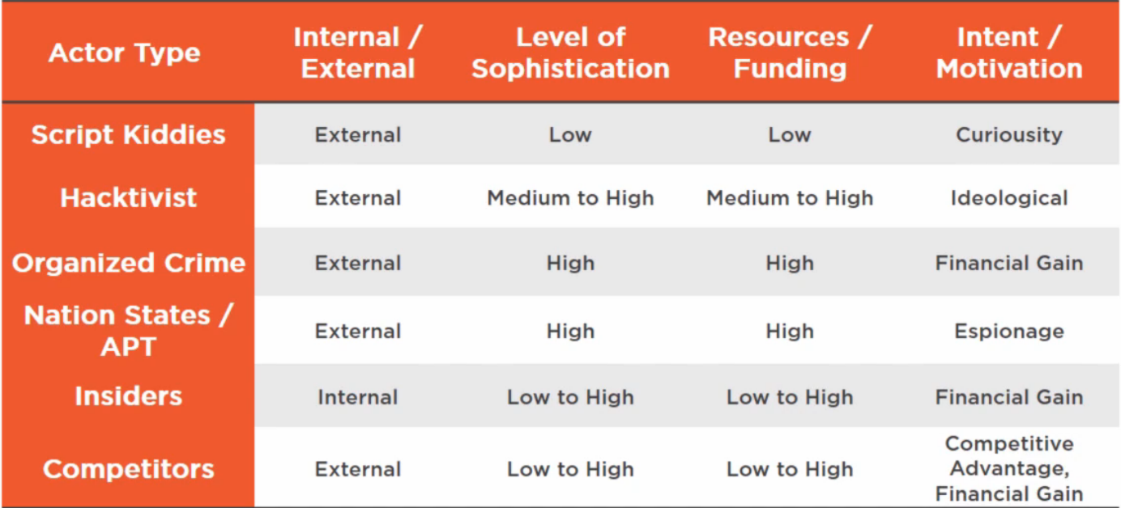

**Security is everyone’s’ business!**

**Attack Vectors**

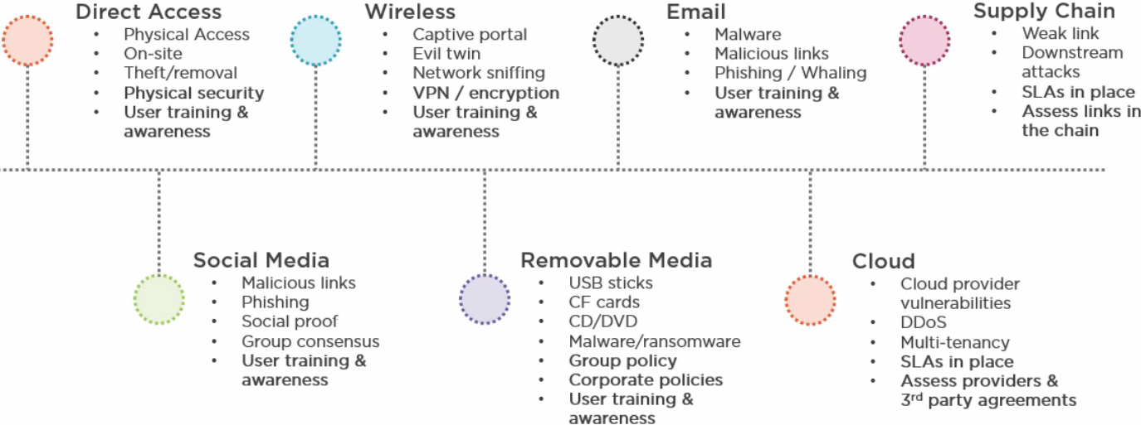

**Use of Open Source Intel**

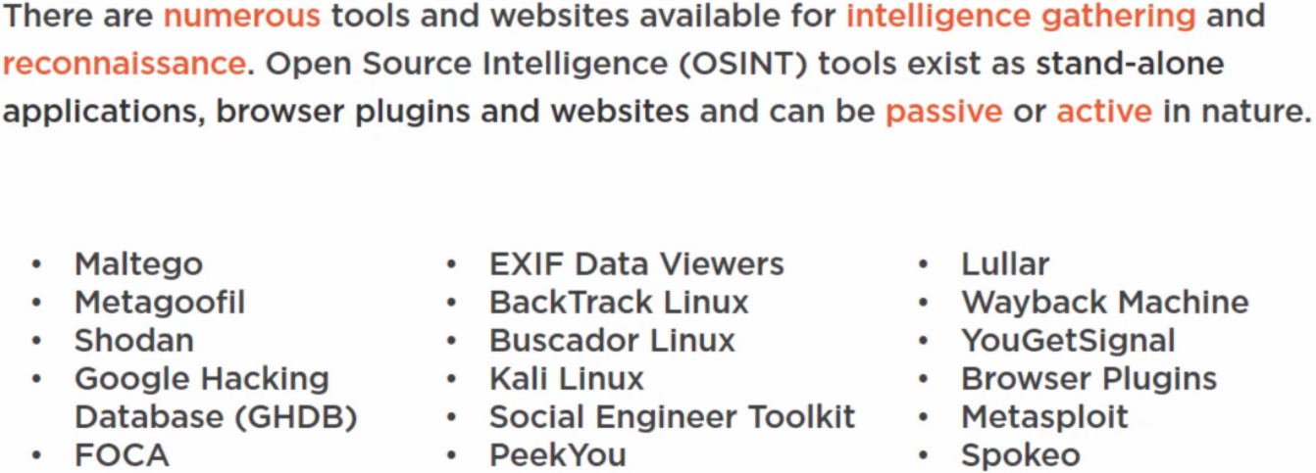

**Closed / Proprietary Intelligence**

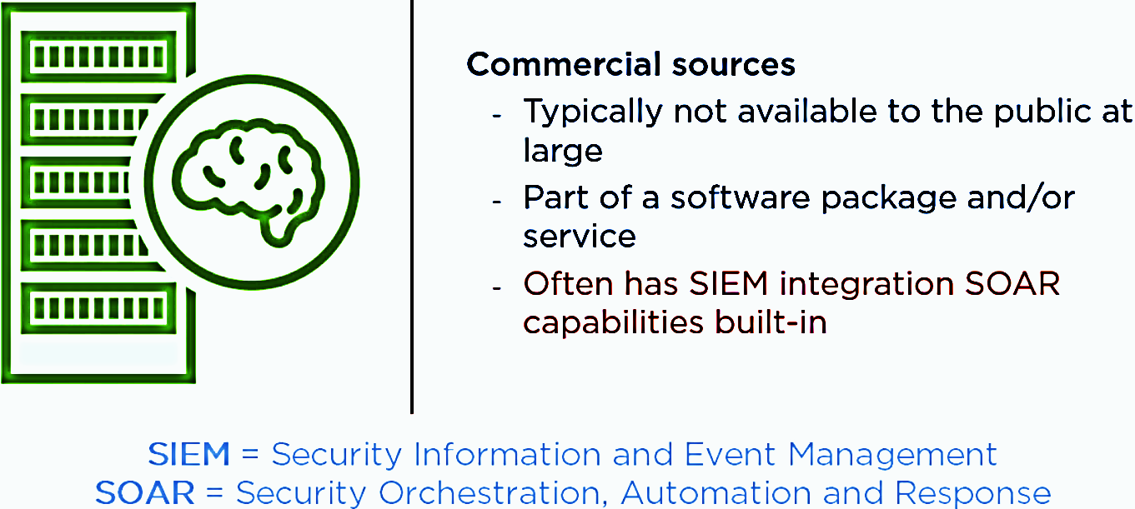

**Vulnerability Databases**

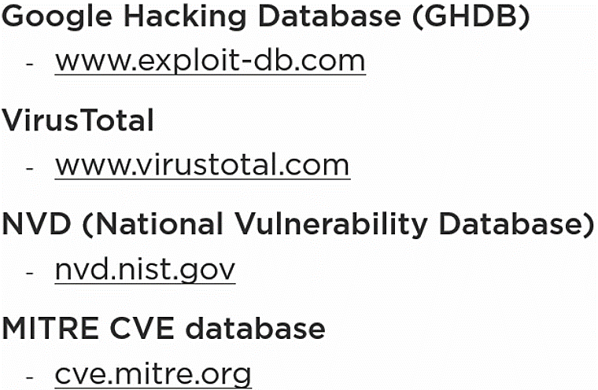

**Public and Private Information Sharing**

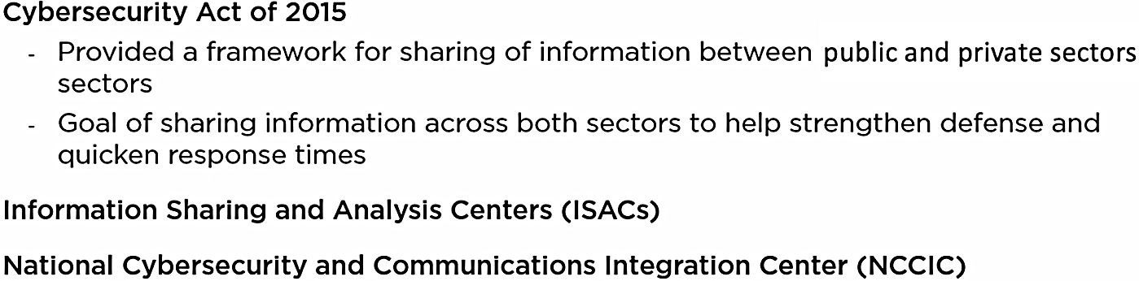

**Dark Web (comprises 90% of all Internet, normal Internet is only tip of Iceberg!)**

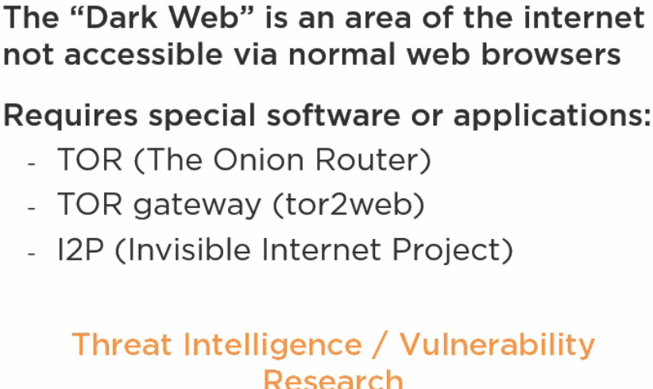

**Indicators of Compromise (IOC)**

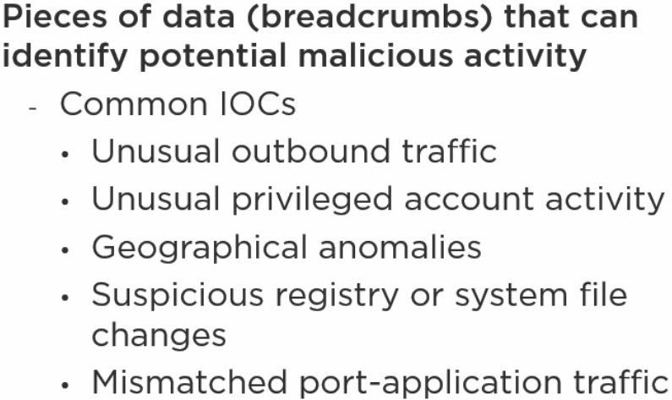

**Automated Indicator Sharing (AIS)**

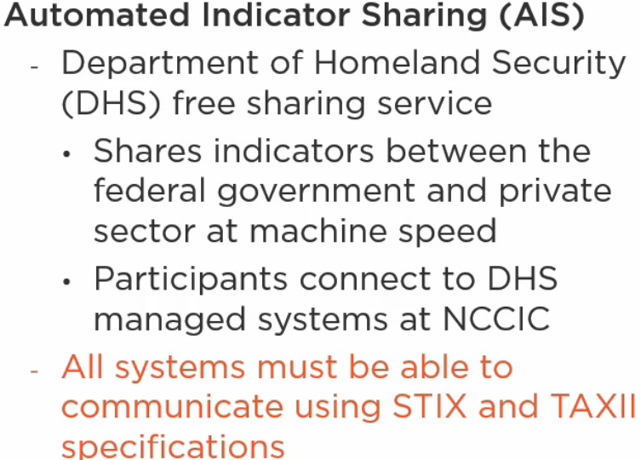

**MITRE**

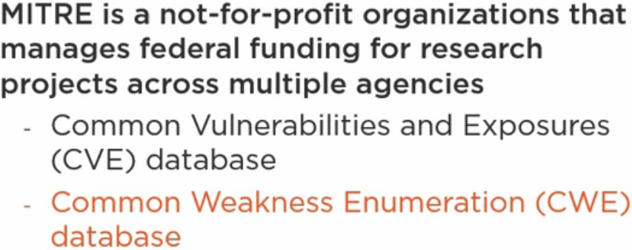

**ATT&CK Framework**

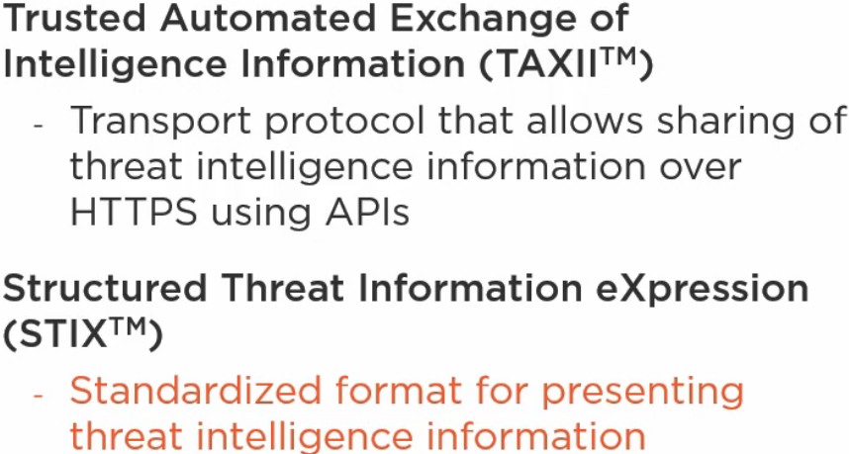

**MITRE ATT&CK: Adversarial Tactics, Techniques and Common Knowledge**

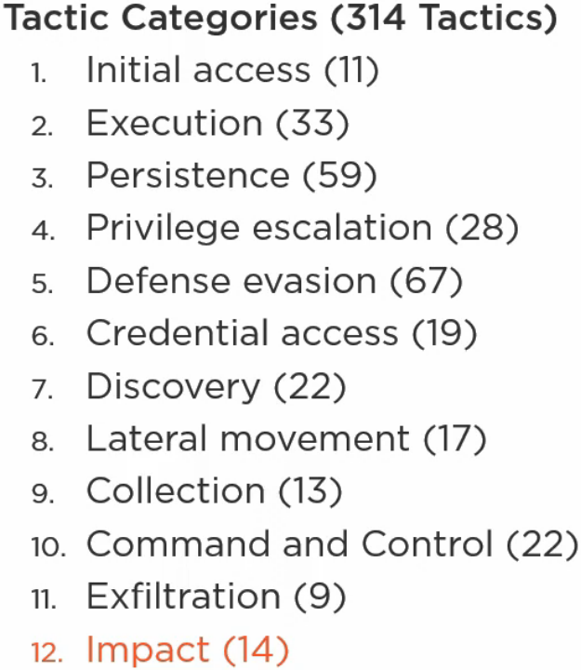

**Gathering and Correlating Information**

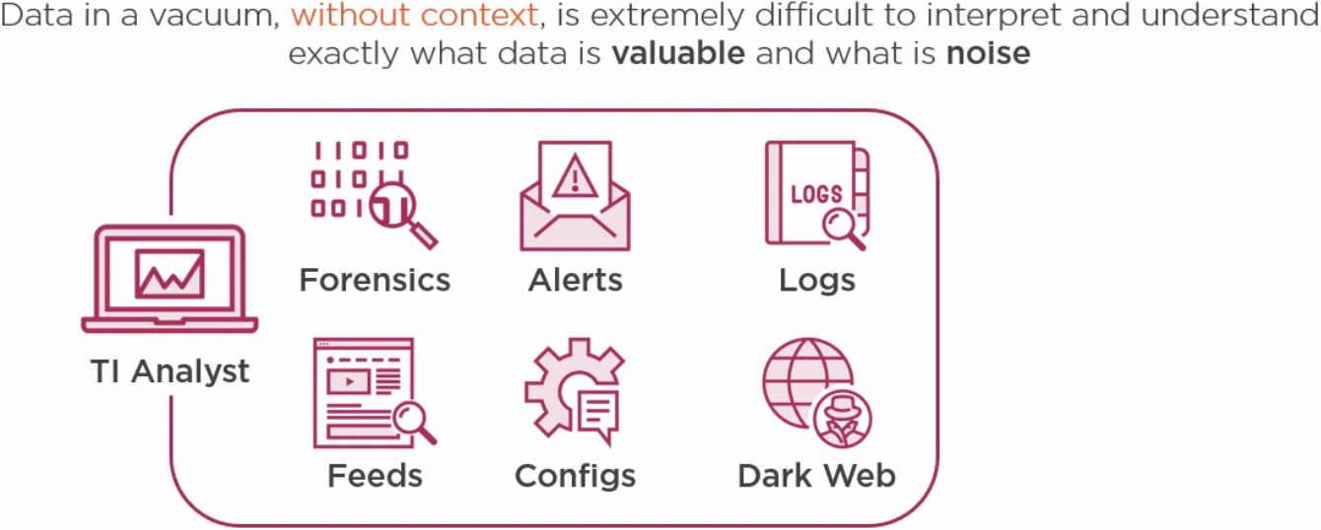

**Predictive Analysis**

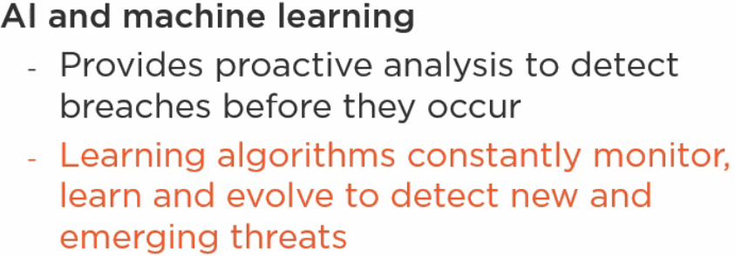

**Threat Maps**

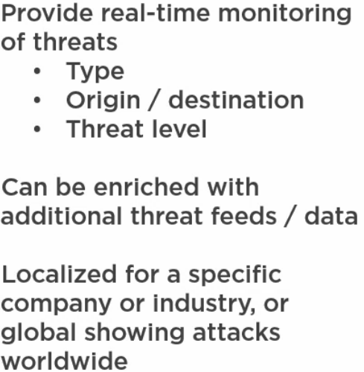

**File / Code Repositories**

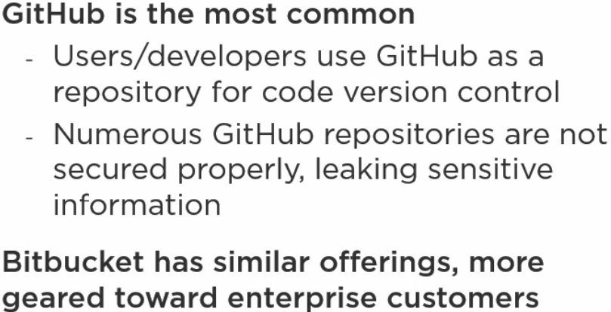

**Research Sources**

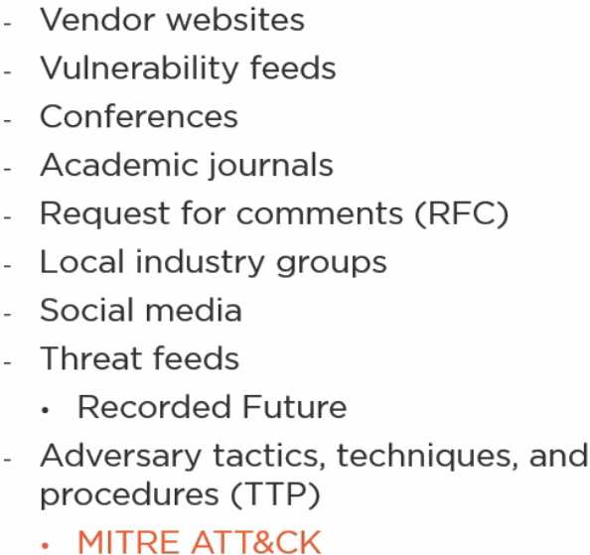

**Cloud-Based Vs. On-Premise**

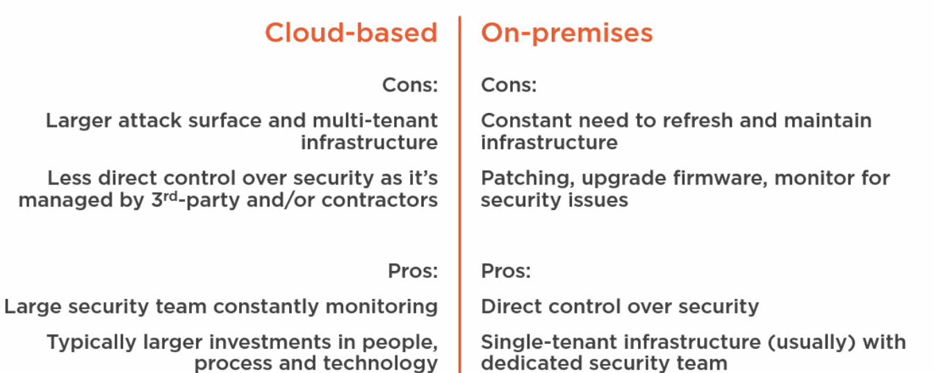

**Misconfiguration / Weak Configuration**

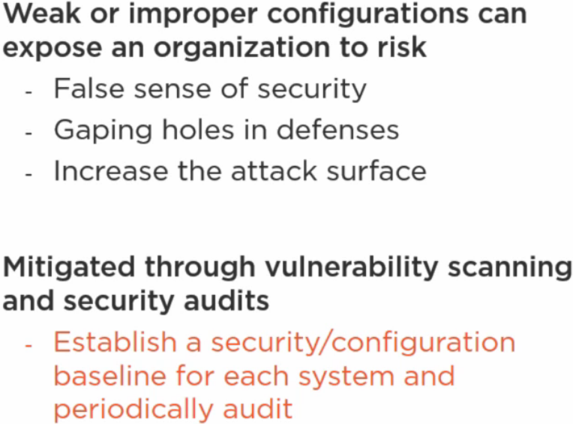

**Shared Accounts (Improperly Configured)**

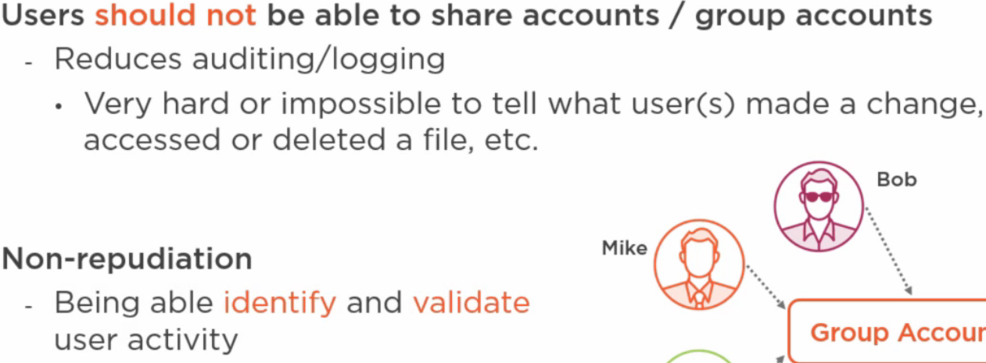

**Weak Configuration Considerations**

* **Open permissions (principle of least privilege)**
* **Unsecured root accounts**
* **Errors (how they are handled**
* **Unsecure protocols**
* **Default Settings**
* **Open ports and services**

**Weak Cipher Suites and Implementations**

